Project Development Phase Model Performance Test

Date | 14 Feb 20226
Team ID | LTVIP2026TMIDS60231
Project Name | ToyCraft Tales: Tableau's Vision into Toy  Manufacturer Data
Maximum Marks

Model Performance Testing:
Project team shall fill the following information in model performance testing template.

S.No. | Parameter | Screenshot / Values
1. | Data Rendered | 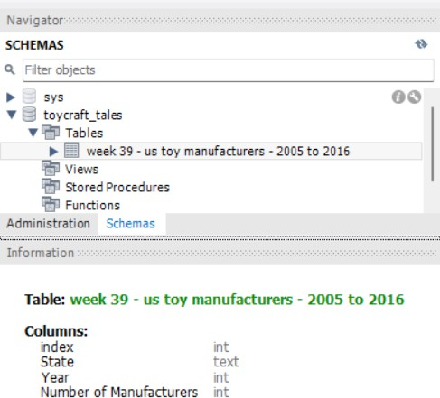  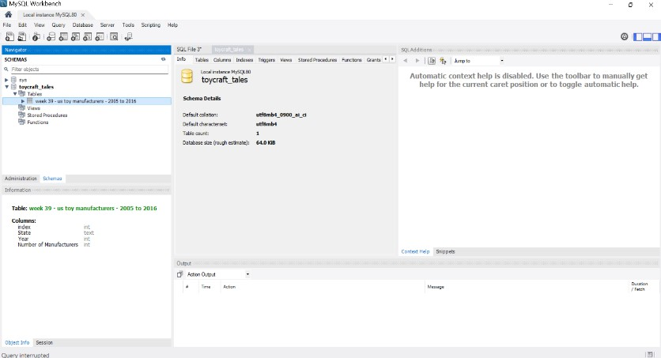

2. | Data Preprocessing | 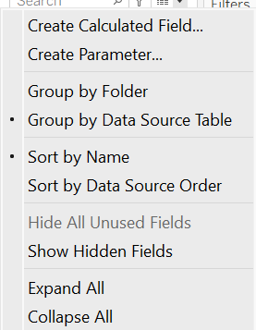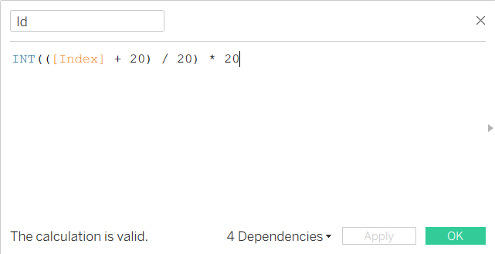  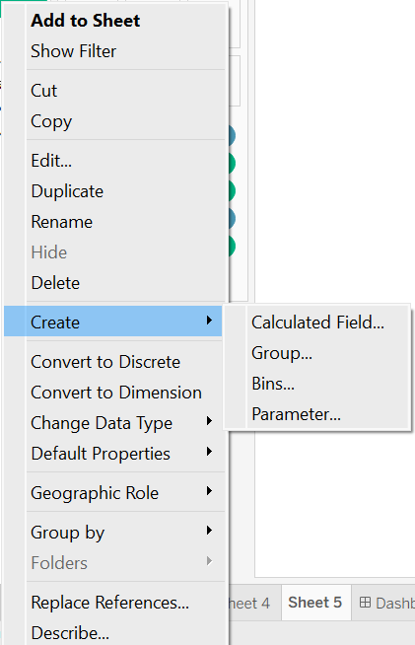

 |  | 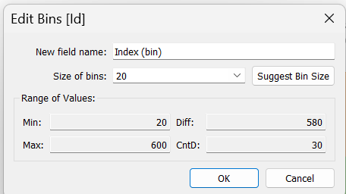
3. | Utilization of Filters | 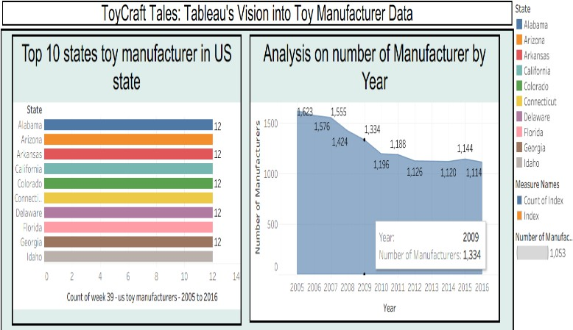  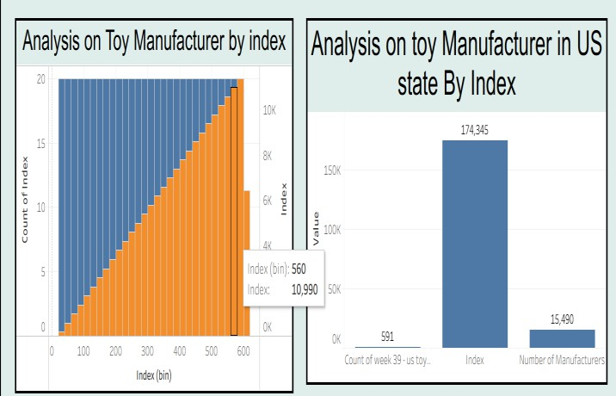  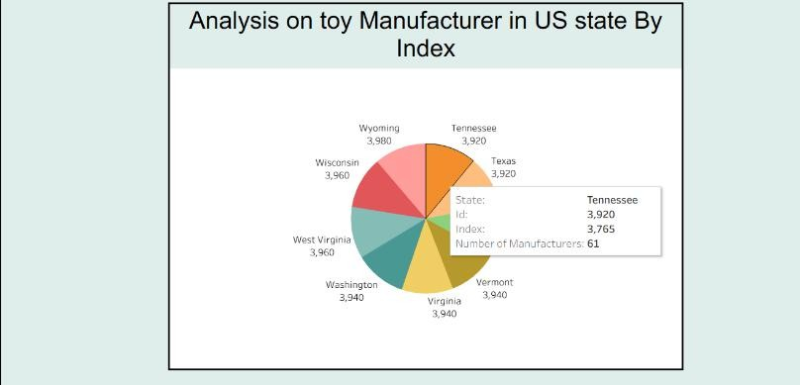

4. | Calculation fields Used | 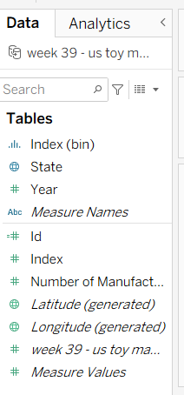
5. | Dashboard design | No of Visualizations / Graphs –  - Analysis of the number of Manufacturers by Year  - Analysis of Toy Manufacturer by Index  - Analysis of toy Manufacturers in US state By Index  - Analysis of Toy Manufacturers  - Top 10 states toy manufacturer in US state  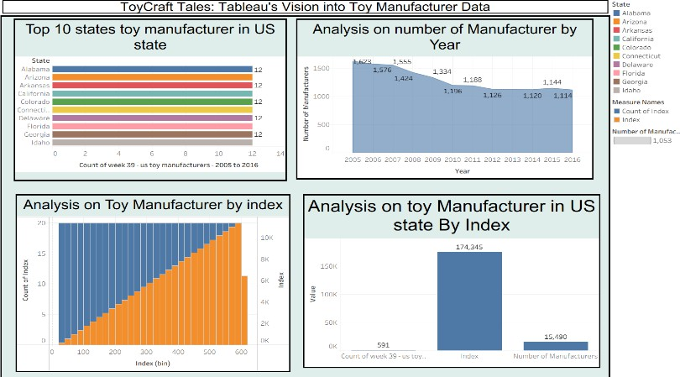

 |  | 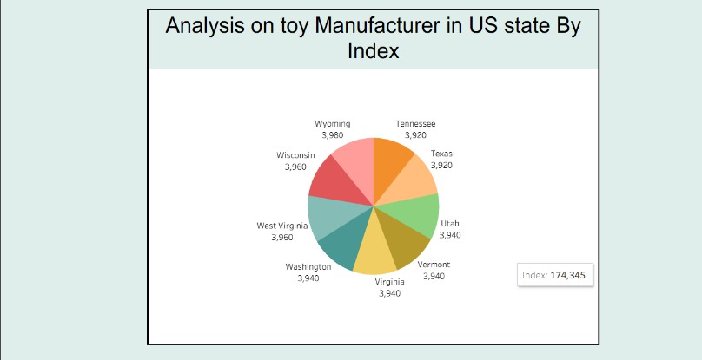
6 | Story Design | No of Visualizations / Graphs –  - Analysis of the number of Manufacturers by Year  - Analysis of Toy Manufacturer by Index  - Analysis of toy Manufacturers in US state By Index  - Analysis of Toy Manufacturers  - Top 10 states toy manufacturer in US state  